Falmouth Harbour seeking new Commissioners and an open recruitment for next Chair
News Release: Immediate
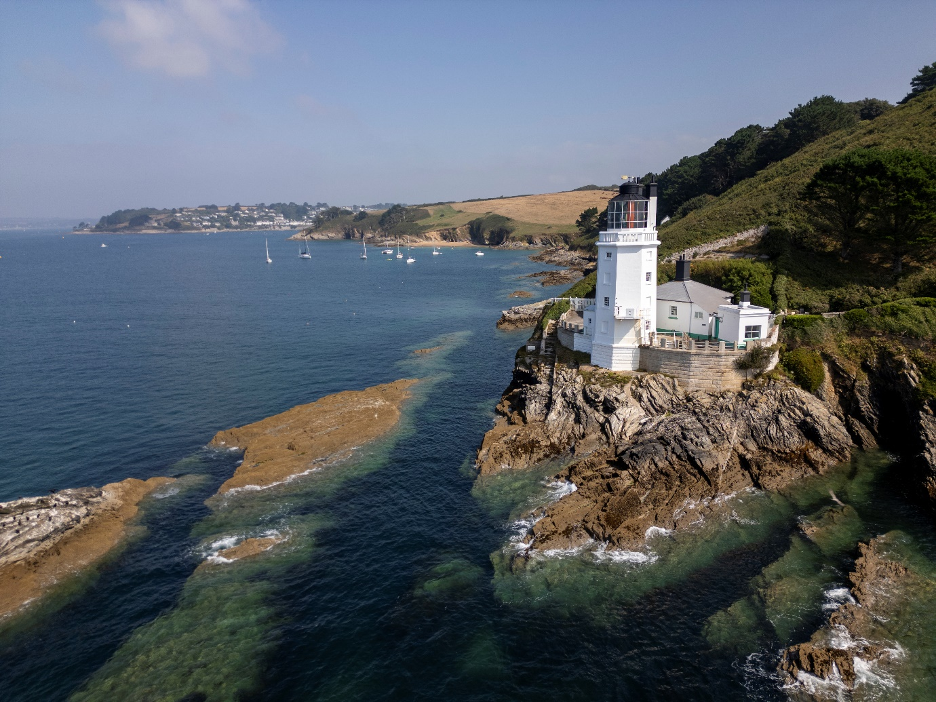
Falmouth Harbour from St Anthony Point. Photo Shark Bay for Falmouth Harbour
Falmouth Harbour is seeking to appoint two new Commissioners to the Board and launching an open and competitive recruitment for its Chair for the next three years from January 1 2026 – roles which will help shape a thriving and sustainable maritime future for the UK’s Atlantic gateway.
The appointments will strengthen the Harbour’s governance at a pivotal time for Cornwall’s most diverse and strategically important port - the 3rd deepest natural harbour in the world on the UK’s Western approaches.
The Harbour Board, with its remit covering Falmouth Harbour, Falmouth Haven and Falmouth Pilot Services, is entering an exciting growth phase with a new Marine Development Masterplan, ambitious sustainability targets and a clear vision to be the UK’s best harbour to invest in, live beside and visit.
The rare appointments will give successful candidates the opportunity to contribute not just to Falmouth Harbour, but to the economic and environmental sustainability of Falmouth and Cornwall. The new Commissioners will add fresh skills and perspectives, ensuring the Board continues to balance commercial growth, leisure, and environmental stewardship.
The Chair role will be openly advertised in line with the Ports Good Governance Guidance, ensuring fairness, transparency and wide competition. The current Chair, Mark Chanter, has confirmed full support for this process and has indicated an intention to apply. All conflict-of-interest safeguards will be observed, with the incumbent taking no part in the recruitment process.
The Board places particular importance on appointing a Community Commissioner to ensure local perspectives are actively incorporated into decision-making. This position underscores Falmouth Harbour’s designation as a Trust Port, managed for the benefit of its stakeholders and the broader community, and serves to uphold the prioritisation of heritage, leisure, environmental considerations, and public access within the Harbour’s strategic framework.
The Harbour is keen to see applications from people with a strong connection to the local community—whether through lived experience, involvement in local organisations, or a strong understanding of the unique opportunities and challenges facing Falmouth and Cornwall.
In addition to this key role, there are a number of areas of expertise that the Harbour is seeking in this round of recruitment, with the Harbour Board particularly interested in hearing from candidates with board level experience - either director or senior management.
Candidates for the Chair role should be an experienced leader with strong governance skills and board-level expertise, able to drive strategic growth, champion sustainability, and strengthen stakeholder relationships.
The Maritime/Shipping Commissioner will ideally have recent commercial shipping, port or pilotage experience with the potential for leading on marine safety compliance.
As these appointments are made Falmouth Harbour also thanks Gerald Pitts and John Elliot who are stepping down after completing their terms of office as Commissioners on the Board which manages the Trust Port - with statutory responsibility for the navigation and conservation of approximately 16 square miles of harbour area.
Gerald has brought a lifetime’s knowledge of the shipping industry and corporate governance oversight that has strengthened the Harbour’s commercial resilience.
John, as a local resident and kayaker, championed the community voice and broader water users and worked closely with Falmouth Harbour’s Pilotage Service, chairing both the Pilotage Standards Committee and the Falmouth Pilotage Services panel.
Falmouth Harbour Chief Executive Miles Carden says, “This is a defining moment for Falmouth Harbour. With two new Commissioners joining and an open search for the next Chair, we are strengthening both governance and ambition. I also want to thank Gerald and John for their outstanding service — their legacy has helped us become a leading, award-winning Harbour.”
Chair Mark Chanter adds, “I’m proud that we are taking this step to open the Chair recruitment. It is right for our stakeholders and it demonstrates our commitment to modern, transparent governance. I will be applying, and I welcome the open process that will ensure the strongest leadership for Falmouth Harbour.”
Anna Jay, MD of Public Leaders Appointments, will be leading the search for our new Chair and Commissioners. Anna says, “Having worked with Falmouth Harbour for a number of years, I am delighted to have the opportunity to lead the search for these critical appointments. The previous three Commissioners appointed through rigorous search have strengthened and diversified the Board, bringing new skills, expertise, and perspectives. This is an exciting time for new Board Members to contribute to the ambitious development of Cornwall’s most diverse and strategically important Harbour.”
Anna launched Public Leaders Appointments eight years ago and works predominantly with public sector and civil society organisations nationwide, advising on and leading board and executive appointments. As a Cornwall resident, she brings a wealth of regional connections in addition to her national networks, and she is passionate about strengthening and diversifying organisations through robust search and selection processes." www.publicleadersappointments.com
The Falmouth Harbour Maritime and Community Commissioners and Chair posts require approximately 2 days’ work per month and they are remunerated.
Applications close at midday on Wednesday 22nd October 2025

