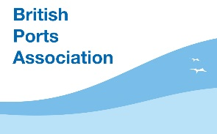

POOLE HARBOUR COMMISSIONERS WELCOMES DELEGATES TO THE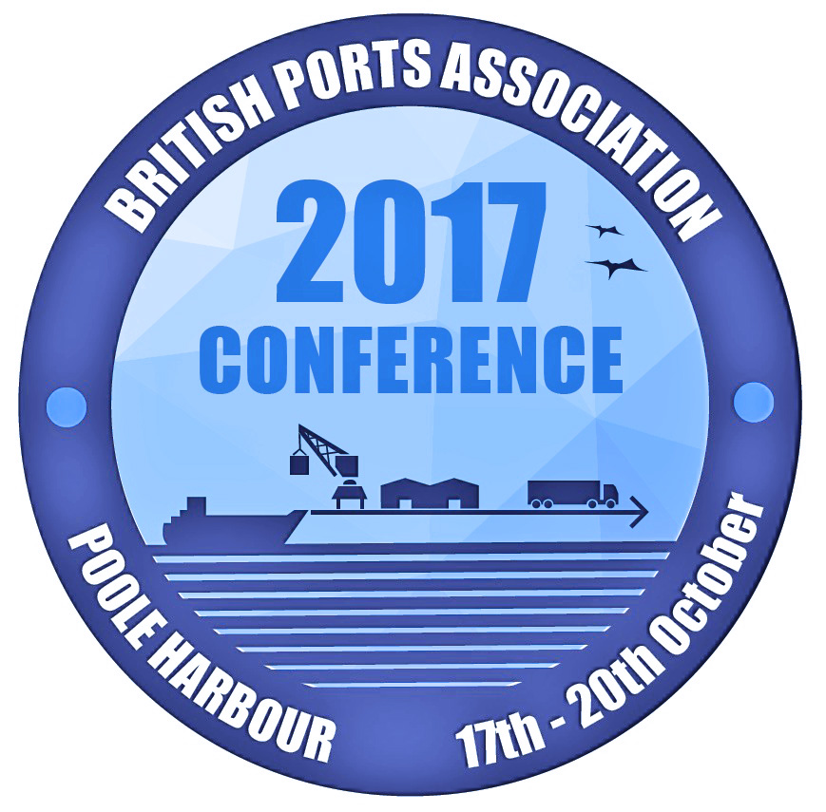

BRITISH PORTS ASSOCIATION CONFERENCE

HOSTED BY POOLE HARBOUR COMMISSIONERS

AT THE HAVEN HOTEL, POOLE HARBOUR

17th, 18th & 19th OCTOBER 2017

Costs
All costs include accommodation, meals, delegate fees and conference events.

3 NIGHTS/2 DAY CONFERENCE: - £695 + VAT FOR BPA MEMBERS
- £795 + VAT FOR NON-MEMBERS

2 NIGHTS/2 DAY CONFERENCE: - £595 + VAT FOR BPA MEMBERS
- £695 + VAT FOR NON-MEMBERS

All costs include accommodation, meals, partners programme and conference events.
3 NIGHTS/2 DAY PARTNER - £325 + VAT
PROGRAMME:

2 NIGHTS/2 DAY PARTNER - £275 + VAT
PROGRAMME:

BOOKING FORM

DELEGATE NAME:

PARTNER’S NAME:

(IF APPLICABLE)

BPA MEMBER/NON-MEMBER:
(YES / NO)

PORT/ORGANISATION:

EMAIL ADDRESS:

CONTACT TELEPHONE NO:

NUMBER OF NIGHTS ACCOMODATION REQUIRED:

(PLEASE SPECIFY DATES)

EXPECTED TIME OF ARRIVAL:

ADDRESS FOR INVOICE:

ADDRESS FOR PARTNERS PROGRAMME INVOICE:

(IF APPLICABLE)

DIETARY REQUIREMENTS:

  - The conference will be held at the spectacular art deco 4-star Haven Hotel, situated on Sandbanks beach (facilities include swimming pool and spa). Accommodation will be at the 4-star Haven Hotel, Sandbanks Hotel or Harbour Heights Hotel.
  - Please note it is not possible to guarantee which hotel you’ll be allocated to.
  - Please see www.fjbcollection.co.uk for hotel details.

Priority will be given to early bookings and bookings must be made through Poole Harbour Commissioners.

All bookings (including accommodation)

must be booked with Annie Willats
Poole Harbour Commissioners, 20 New Quay Road, Poole BH15 4AF
Email: anniewillats@phc.co.uk - Telephone: (01202) 440210

CONFERENCE EVENTS

Please indicate if you wish to be involved in the following events.

We need to confirm numbers well in advance of the conference.

Book early to avoid disappointment

Tuesday 17th October – 6 pm

Welcome drinks reception at The Haven Hotel, Sandbanks.

Wednesday 18th October – 6 pm

Poole Harbour tour, evening reception at the RNLI College, followed by drinks on Poole Quay.

Thursday 19th October – 7 pm

Drinks reception, gala dinner and live music at The Sandbanks Hotel.

Friday 20th October (time tbc)

Morning tour of the Port of Poole.

Friday 20th October – 9.30 am

BPA Golf Championship at Ferndown Golf Club Poole, rated one of UK’s top 30 golf courses.

This will cost an additional £80 which includes breakfast, lunch and prizes.

Limited spaces - early booking is essential.

Please specify any special dietary requirements.

Exhibitors and Sponsorship packages are available Contact Annie Willats at anniewillats@phc.co.uk

or telephone (01202) 440210 for details

PARTNERS PROGRAMME

Please indicate if your partner wishes to be involved in the following events.

We need to confirm numbers well in advance of the conference.

All partners will receive a £25 gift voucher to use at the Haven Hotel Spa facilities

Wednesday 18TH October

Boat trip to Brownsea Island, including a private tour of Brownsea Castle and a guided tour of Dorset Wildlife Trust nature reserve featuring red squirrels. Lunch will be provided at Rick Stein Sandbanks.

There will also be time for spa treatments in the afternoon at the Haven Hotel. (booking required)

Thursday 19TH October

Trip to Hardy Country including Sculpture by the Lakes (created by internationally acclaimed sculptor Simon Gudgeon), followed by a private tour of Minterne House and gardens with Lord Digby and a tour of the Isle of Purbeck (lunch and cream tea provided).

Please specify any special dietary requirements.

All bookings (including accommodation)

must be booked with Annie Willats
Poole Harbour Commissioners, 20 New Quay Road, Poole BH15 4AF
Email: anniewillats@phc.co.uk - Telephone: (01202) 440210

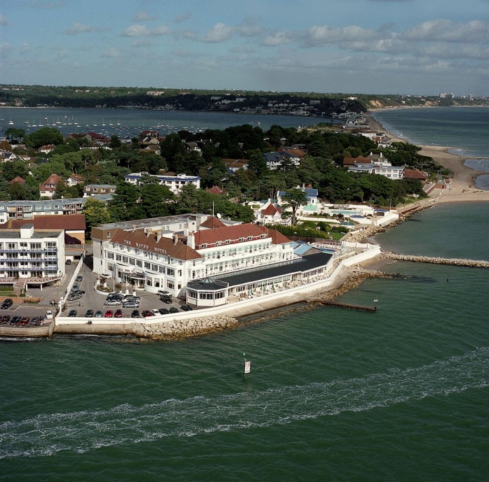
HAVEN HOTEL, SANDBANKS, POOLE
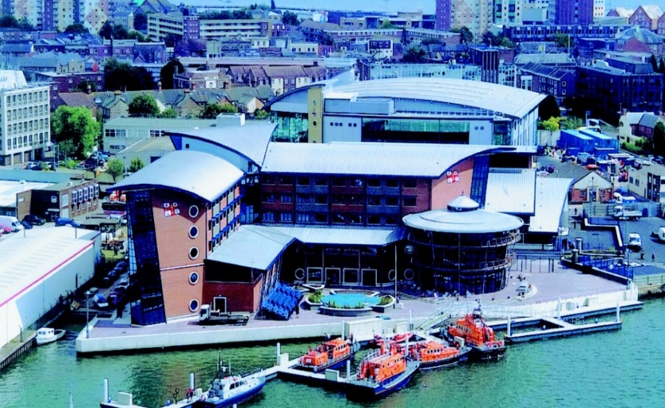
RNLI POOLE
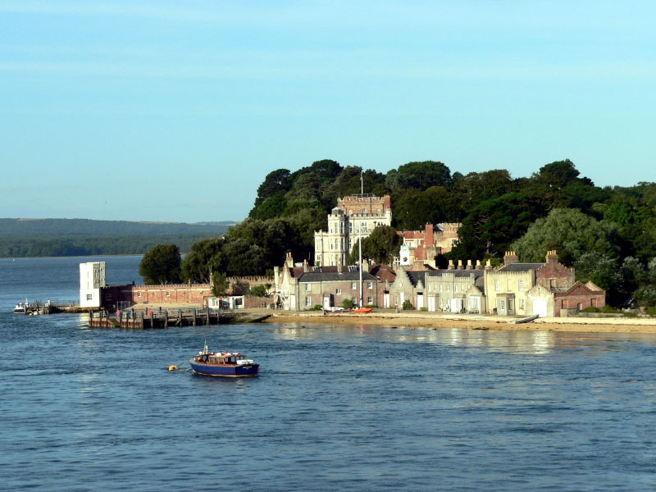
BROWNSEA CASTLE

Useful websites:

www.college.rnli.org

www.ferndowngolfclub.co.uk

www.sculpturebythelakes.co.uk

www.dorsetwildlifetrust.co.uk

www.nationaltrust.org.uk/browsea-island

